|  |  |  |
| --- | --- | --- |
|  |  | PROFILE |
|  | Seeking challenging and growth-oriented assignment within progressive account in the organization. Have an excellent track record of successful maintaining Team relationship, self-motivated team player with a result-oriented management style, excellent communication, and management skills, with strong technical and analytical abilities. |
| Mohd Adnan UDDIN   ProfileCONTACT PHONE:  (+91) 81870-25308  EMAIL:  adnaanit06[@gmail.com](mailto:adnaanit06@gmail.com) ACHIEVEMENTS  * Won Gold Medal for my performance in SSC |  | Technical summary |
|  | * Proficient in **Python** programming language * Proficient in business logic languages such as **C, Java** * Proficient in Front end Technologies such as **HTML**, **Javascript**, and **CSS** * Proficient in concepts of Object oriented Programming * Excellent communication skills * Ability to adapt to any work environment * Ability to deliver solutions standalone and work in Teams. * Problem solving ability * Exposure to Cloud Technologies such as Salesforce |
|  | SKILLS |
|  | |  |  | | --- | --- | | **Software Languages** | 1. Python 2. C 3. Java 4. HTML 5. CSS 6. JavaScript 7. Salesforce Basics | | **Packages** | MS Office | | **Tools Used** | VS Code, PyCharm, Notepad++ | | **Software Methodology** | Agile | |

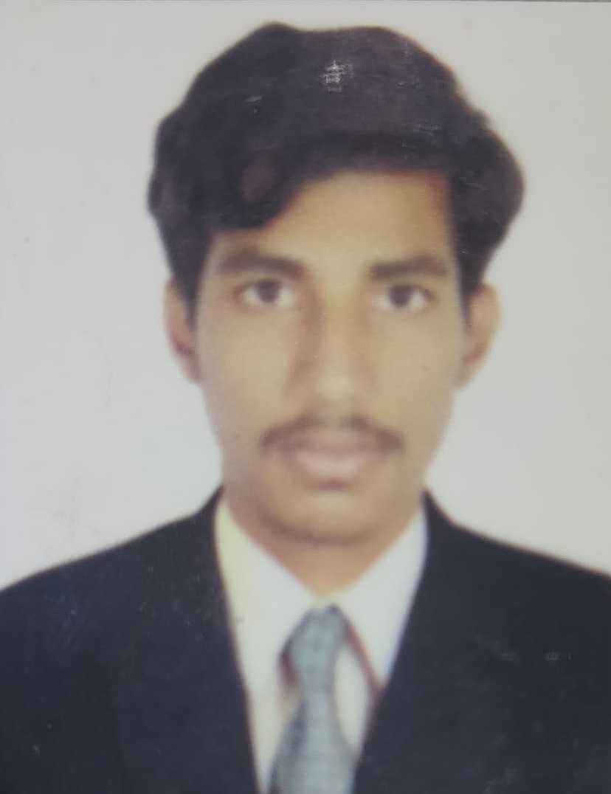

|  |  |
| --- | --- |
|  | Education |
|  | |  |  |  |  | | --- | --- | --- | --- | | Degree | University/Board | Passout Year | CGPA | | B.Tech (I.T) | IARE, Hyderabad | 2023 (Persuing) | 7.2 | | Diploma in Education | State Board of Technical Education, Telangana | 2020 | 72.13% | | SSC | Board of Secondary Education, Telangana | 2017 | 8.5 | |

|  |  |  |
| --- | --- | --- |
|  | PERSONAL DETAILS | |
| |  |  | | --- | --- | | Name | Mohd Adnaan Uddin | | Date of Birth | 07-08-2002 | | Status | Single | | Permanent Address | H.no: 1-5-73, Phulong street, Nizamabad | | Father Name | Khatib Moinuddin | | Language | English, Hindi, Telugu | | Nationality | Indian |   I hearby declare that all the information provided is correct to the best of my knowledge.  Yours Faithfully  Mohd Adnaan Uddin | |